Name: Ronak Panchal

Roll no.: 22BCP192

Experiment - 1

Aim: Simulation of Various Networking Topologies

Outcome: To Impart knowledge of Computer Network Technology

Theory:

1. Point to point topology

* This is a type of topology is straightforward and efficient. hen two devices need to communicate, they establish a direct connection, typically through cables or wireless links. This direct link ensures fast and secure data transfer, as there’s no interference from other devices on the network.

1. Star topology

* It is the most common network topology in which each network node is connected to a central device such as a switch. When a cable in the star network breaks, just attach the disconnected node from cable to central device. The other nodes can continue to operate properly.
* Star topologies are frequently used in local area networks. When you have a small network that utilizes a switch or hub to connect multiple devices, you can use star topology. It can achieve very high data transmission rates, especially when the star coupler is employed in the switch mode.

1. Bus topology

* In this type of topology nodes are connected in a line. Every node on the network can monitor every packet delivered on the cable in a bus topology.
* There is a disadvantage in this topology because if the cable in a network breaks, the entire network is disabled but the nodes on opposite sides of the break can continue to interact with each other.

1. Ring topology

* In this topology packets are passed from computer to computer. Each computer examines every packet to see whether it was meant for that computer.

1. Mesh topology

* In mesh topology each node is connected to others and can send and receive data as well as information from other nodes. In this each node must have multiple connections to the other nodes.
* This topology becomes more practical with Wi-Fi networks. Mesh topology is the best network topology which describes the Internet.

1. Hybrid topology

* Hybrid topology combines elements of many different topologies. Star-ring and star-bus are the two most common hybrid topologies.
* It combines the advantages of different topologies and, when performed properly, this form of topology is very adaptable and scalable.

Procedure:

1. Open Cisco Packet Tracer and simulate the topologies of the required size.
2. Assign the IP Addresses to the system.
3. Check the connectivity between the devices.

Output:

1. Point to point topology

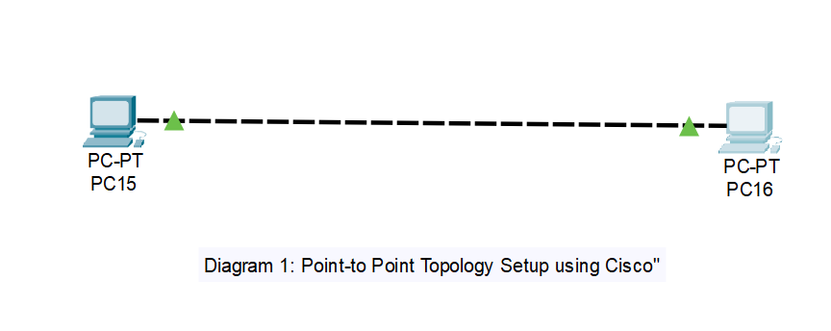

1. Star Topology

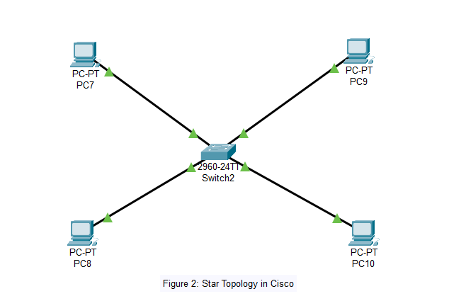

1. Bus Topology

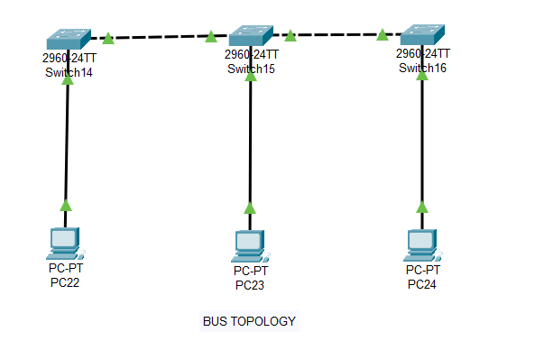

1. Ring Topology

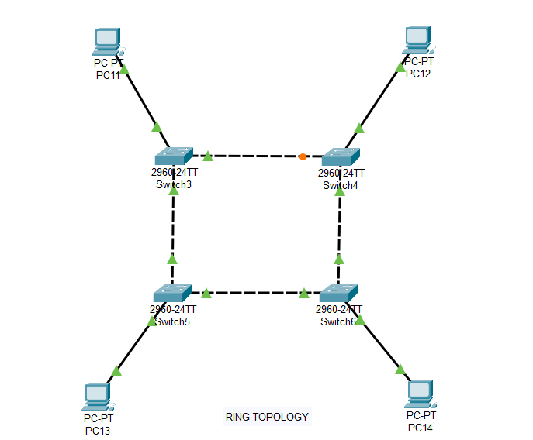

1. Mesh Topology

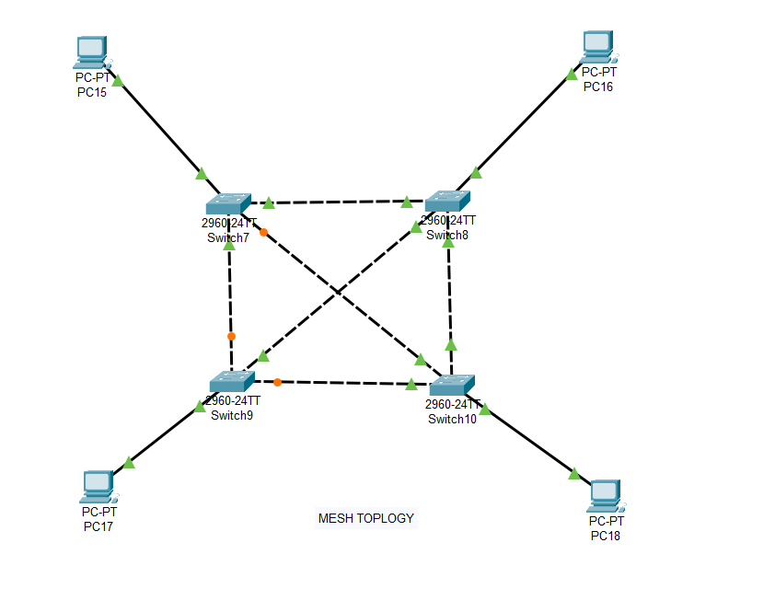

1. Hybrid Topology

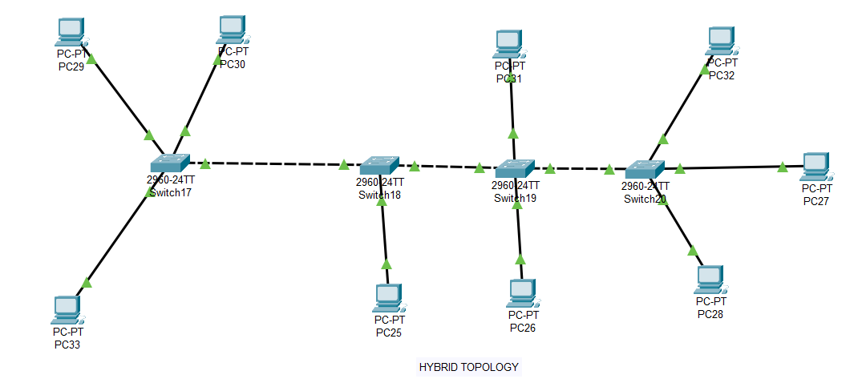

Observation & Learning:

1. Network topologies like star and mesh generally show high performance due to direct connections and multiple data paths. Bus and ring topologies may face performance issues as the network grows.
2. Mesh topology offers the highest fault tolerance with redundant paths. Star topology provides good fault tolerance except for central hub failures. Bus and ring are more vulnerable to single points of failure.
3. Star and hybrid topologies are more scalable, allowing for easier addition of devices. Bus and ring topologies are less scalable and require careful planning.
4. Mesh topology is the most complex and expensive due to the number of connections. Star topology strikes a balance between complexity and cost.

Conclusions:

Efficiency and Performance: Star and mesh topologies are generally more efficient and perform better, especially in larger networks.

Fault Tolerance: Mesh topology is the most fault-tolerant, followed by star topology.

Scalability: Star and hybrid topologies are easier to scale compared to bus and ring topologies.

Complexity and Cost: Mesh topology is the most complex and costly, while star topology offers a good balance of complexity and cost.

Questions:

1. Which is the most efficient topology in LAN environment and why?

Ans. Star topology is the most efficient for LAN environments due to its high performance, fault tolerance, scalability, ease of troubleshooting, and cost-effectiveness.

1. How we can test the connectivity between the terminals?

Ans. Using ping Command:

1.)Open Terminal: On both machines.

2.)Ping the Target Machine: In the terminal of one machine, type ping [IP Address or Hostname].

1. What are the two categories of cable? In what type of connection they are used?

Ans. Two types of cables are:

1. Twisted pair cable

Types:

Unshielded Twisted Pair (UTP): Most common type.

Shielded Twisted Pair (STP): Includes shielding to reduce electromagnetic interference.

Usage:

Ethernet Networks: Commonly used for LAN connections.

Cat5e: Supports up to 1 Gbps over short distances.

Cat6: Supports up to 10 Gbps for distances up to 55 meters.

Cat6a: Supports up to 10 Gbps for distances up to 100 meters.

Telephone Lines: UTP cables are used in traditional telephone networks. DSL Connections: Used in broadband internet connections over telephone lines.

1. Fibre Optic cable

Types:

Single-Mode Fiber (SMF): Uses a single light mode, ideal for long-distance communication.

Multi-Mode Fiber (MMF): Uses multiple light modes, suited for shorter distances.

Usage:

Backbone Networks: Connects different network segments and data centers.

Internet Infrastructure: Provides high-speed internet connections between ISPs.

Long-Distance Communication: Used in undersea cables and long-distance telephone networks.

High-Speed Data Transfer: Preferred for applications requiring high bandwidth and low latency, such as data centers and high-speed broadband connections.